Blockchain Based E-commerce DApp
Project Report Submitted in Partial Fulfilment of the Requirements for the Degree of

Bachelor of Engineering
in
Computer Science and Engineering
Submitted by
Ankit Singh Rathore: (Roll No. 19UCSE4003)
Ravindra Jangid: (Roll No. 19UCSE4017)

Under the Supervision of
Mrs. Simran Chaudhary
Assistant Professor


Department of Computer Science and Engineering
MBM University, Jodhpur
June, 2022
This page was intentionally left blank.
Blockchain Based E-commerce DApp

Project Report Submitted in Partial Fulfilment of the Requirements for the Degree of

Bachelor of Engineering
in
Computer Science and Engineering

Submitted by
Ankit Singh Rathore: (Roll No. 19UCSE4003)
Ravindra Jangid (Roll No. 19UCSE4017)

Under the Supervision of
Mrs. Simran Chaudhary
Assistant Professor

Department of Computer Science and Engineering
MBM University, Jodhpur
June, 2022
This page was intentionally left blank.

Department of Computer Science & Engineering
MBM University, Jodhpur, Rajasthan, India –342011

CERTIFICATE

This is to certify that the work contained in this report entitled “Blockchain Based E-commerce DApp” is submitted by the group members Mr. Ankit Singh Rathore (Roll. No: 19UCSE4003) and Mr. Ravindra Jangid (Roll No: 19UCSE4017) to the Department of Computer Science & Engineering, M.B.M. University, Jodhpur, for the partial fulfilment of the requirements for the degree of Bachelor of Engineering in Computer Science and Engineering.
They have carried out their work under my supervision. This work has not been submitted else-where for the award of any other degree or diploma.
The project work in our opinion, has reached the standard fulfilling of the requirements for the degree of Bachelor of Engineering in Information Technology in accordance with the regulations of the Institute.

Simran Chaudhary
Assistant Professor
(Guide)
Dept. of Computer Science & Engg.
MBM University, Jodhpur
Prof. N. C. Barwar
(Head)
Dept. of Computer Science & Engg.
MBM University, Jodhpur
This page was intentionally left blank.

DECLARATION
We, Ankit Singh Rathore and Ravindra Jangid, hereby declare that this project titled “Blockchain Based E-commerce DApp” is a record of original work done by us under the supervision and guidance of Simran Choudhary.
We, further certify that this work has not formed the basis for the award of the Degree/Diploma/Associateship/Fellowship or similar recognition to any candidate of any university and no part of this report is reproduced as it is from any other source without appropriate reference and permission.

SIGNATURE OF STUDENT
(Anki Singh Rathore)
8th Semester, CSE
Enroll. - 18R/06177
Roll No. - 19UCSE4003

SIGNATURE OF STUDENT
(Ravindra Jangid)
8th Semester, CSE
Enroll. - 18R/06198
Roll No. - 19UCSE4017

This page was intentionally left blank.

ACKNOWLEDGEMENT
We, Ankit Singh Rathore and Ravindra Jangid would sincerely like to thank Professor Nemi Chand Barwar, Head of Department, Computer Science & Engineering, MBM University, Jodhpur for the support and availability of facilities by the department.
We wish to express my deepest sense of gratitude to Professor Anil Gupta and Assistant Professor Simran Chaudhary, for their able guidance and useful suggestions that helped us in completing the project work, on time. Their guidance, encouragement, suggestion, and constructive criticism have contributed immensely to the evolution of our ideas on the project.
Finally, yet most importantly, I would like to express our heartfelt thanks to our family, friends, and peers for their blessings, wishes, and support for the successful completion of this project.
This page was intentionally left blank.
ABSTRACT
Blockchain technology is taking on an increasingly important role in the global economy. The benefits of blockchain in ecommerce extend from faster, cheaper business processes to greater data security and an improved customer experience. Because blockchain makes transactions safer and faster, the potential impact on ecommerce is tremendous.
So, in our final year project we are developing an E-Commerce DApp. Advantages it has over traditional e-commerce websites are data security, faster transactions and no centralized organization is involved.
In this DApp, sellers upload their products and stock, there is no centralized org so every seller gets equal opportunity. When buyer buys any product, they have to pay in ethers which are initially stored in smart contracts and release to seller only when buyer receive the product and satisfied with it, if buyer don’t get the product on time, then the ethers are revert back to buyer. And when buyer receive the product and satisfied with it, then only those ethers are transferred to the seller. So, there is a trust between both seller and buyer that this transaction is not fraudulent. It also provides data security, both seller and buyer have assurance that their personal data is free from data breaches.
This page was intentionally left blank.

Contents
- Introduction | 1
  - Project introduction
  - Centralized VS Decentralized
  - Why we should use Blockchain?
- History & Evolution  - History  - Evolution | 7
- E-commerce DApp  - DApps (Decentralized Applications)  - Technologies Used | 11
- Project Details  - Seller’s Journey  - Buyer’s Journey | 17  27
- Conclusion & Future work
  - Conclusion
  - Future work

References…………………………………………………………………….. | 29

List of Figures
1.2 Code execution process  3.1 React.js components flow | 5  17

Chapter 1
INTRODUCTION
  - Project introduction
This project merges together a wide range of technologies associated with distributed systems, in an effort to provide a scalable but yet decentralized solution to electronic commerce, where there doesn’t need to be one or more entities controlling all the information and processes for all parties involved in digital trade. It takes advantage of the advances in decentralization provided by blockchain and smart contracts while manoeuvring around its shortcomings with other technologies, namely trusted compute.
To manage the Ethereum accounts, the main tools used were Metamask and Infura. Infura provides a remote Ethereum node to be able to interact with Ethereum without having to run our own node, while metamask is a browser plugin that once installed creates a few key pairs to be used as accounts on Ethereum. The Hardhat tool is used to create a local blockchain simulation. The web client is based on React library was a big component. The web3.js library collection was used in the web client to interact with the remote Ethereum node in making transactions and fetching data from the blockchain.
    - Context
International electronic commerce is concentrated to a few large companies such as eBay, Amazon, AliExpress, and Wish. This level of centralization in the way we conduct our trades is unprecedented in human history and gives away immeasurable power to a few large entities, therefore making the general population more controllable and paving the way for the deterioration of our freedoms.
A database usually structures its data into tables, whereas a blockchain, as its name implies, structures its data into chunks (blocks) that are strung together.
    - Motivation
As centralized electronic commerce platforms have middleman expenses and can easily collaborate when setting fees on goods sold due to being few in number, fees on these platforms are expected to be high. There’s also the issue of the censorship forced on by governments and the platform owner’s ideals and beliefs, and the lack of privacy as we need to provide our name, address, contact and payment methods to these centralized entities.
    - Objective
The main objective of this work is to explore a way to remove the middleman from our online commerce while still retaining the features and characteristics present in centralized e-commerce
  - Centralized VS Decentralized
    - Centralized
Centralization refers to a central location or group of managerial personnel responsible for planning, decision-making, and action-taking activities. All of this organization’s significant rights and powers lie in senior management’s hands.
In the past, using the centralization approach was common to keep all of its powers in one place. As a result, higher-ups had complete control over middle and lower-level management’s actions. Apart from that, personal leadership and coordination are evident, as is the ease of dispersed work among staff.
Benefits:
- A transparent communication chain assists a centralized organization since everyone knows who to report to. When junior employees have problems with the company, they know who to contact. On the other hand, senior executives have a well-defined framework for distributing responsibility to staff who excel in specialized activities. When a company wants to make decisions swiftly and uniformly, a transparent chain of command is advantageous.
- When an organization has a centralized management structure, it may easily focus on achieving its vision. There are open communication channels and the senior executive may express the organization’s objective to employees while also guiding them toward achieving it. The top-down direction of an organization’s vision provides a straightforward implementation of its visions and plans. As a result, customers, suppliers, and communities all receive a consistent message from the organization.
- A centralized company follows standard operating processes and methods, which helps cut down on office and administrative expenditures.T here is no need to deploy more divisions or equipment to other sites because the company’s main decision-makers are based there. Furthermore, because critical decisions are made at the corporate level and then disseminated to the branches, the company does not need to spend additional funds on employing specialists.
- In a centralized organisation, a small number of people make decisions and relay them to lower-level administrators. The decision-making process is more efficient when involving only a few people. The decisions are subsequently relayed to the organization’s lowest levels for implementation.
- A centralized organization’s established procedures and greater oversight result in higher work quality. Each department has a supervisor who ensures that the output is consistent and of good quality.
Cons:
- centralized management is similar to totalitarian leadership in that staff only perform to generate outcomes based on what the top executives assign them. Employees are unable to contribute to the organization’s decision-making process and are only implementers of decisions taken at a higher level. CEOs will not comprehend when employees have difficulty implementing some decisions since they are only decision-makers and not decision-implementers. As a result of such activities, performance suffers because employees lack the desire to participate in decisions made by only top-level managers.
- The management of the company is under a lot of pressure to make decisions for the company, yet they have no influence over the implementation. The inability of executives to decentralize decision-making adds a large amount of work to their desks. As a result, executives may make an excessive number of decisions that are either poorly implemented or ignored by staff.
- Because records move to and from the central office, there are delays in work. Employees rely on information conveyed from the top, and any delays in conveying the records will result in a loss of person-hours. In addition, employees will be less productive if they wait for long periods for instructions on their following initiatives.
    - Decentralized
Decentralization is a firm structure in which multiple levels of the organisation make choices. To make measuring the company’s success and the staff inside each of the sub-groups easier, decentralized firms are generally divided down into smaller segments or groups.
Many businesses operate in extremely competitive markets and industries. Therefore, a firm must work hard to build strategic competitive advantages that set it apart from its competitors to be successful.
To do so, the organizational structure must enable the firm to change and capitalize on possibilities quickly. As a result, to maintain a competitive advantage, many firms adopt a decentralized management structure.
Benefits:
- It is critical that decisions be taken and implemented as soon as possible. In addition, firms must capitalize on opportunities that align with their overall strategy to remain competitive.
- It is critical for firms to always look for new ways to supply goods and services to their customers.
- Organizations must invest in training highly skilled people who can make informed judgments that help the organization achieve its goals.
- A pay raise frequently accompanies promotional possibilities. Moreover, in a decentralized business, a pay raise is frequently accompanied by additional duties such as learning new skills, having more decision-making authority, and supervising other employees.
- A company needs to accomplish several tasks in order to succeed. Lower and middle management frequently performs many of these activities in decentralized businesses. Managers can develop essential experience and competence in various areas due to this.
Cons:
- Problems with coordination are critical for an organization to operate toward a common purpose. Because decision-making in a decentralized organization is delegated, it can be difficult to verify that all company sectors are working together to fulfil its strategic goals.
- Because it is must to undertake similar choices and activities across all divisions of an organization, decentralized businesses are prone to duplication of efforts, resulting in inefficiency and higher costs.
- When authority is distributed throughout the organization, as it is in decentralized organizations, division managers may be motivated to customize its operations to maximize efficiency and serve its best interests. In this arrangement, it is vital to ensure that one division’s shortcuts do not conflict with or disrupt the operations of another division.
- It is usual for different divisions within an organization to be rated on division success rather than company performance. In a decentralized organisation, division managers can prioritise divisional aims over organisational goals. Leaders of decentralized organizations must ensure that the organization’s goals are prioritized and met by all divisions.
- Because decentralized companies have a high amount of autonomy, divisions may become operationally disconnected from other divisions, focusing solely on the division’s priorities.
- In addition, due to a lack of access to other professionals, if divisional or departmental managers lack a varied variety of expertise or talents, the division may be at a disadvantage.
1.3. Why we should use Blockchain?
As we now know, blocks on Bitcoin’s blockchain store data about monetary transactions. Today, there are more than 10,000 other cryptocurrency systems running on blockchain. But it turns out that blockchain is actually a reliable way of storing data about other types of transactions as well.
1.3.1 Banking and Finance
Perhaps no industry stands to benefit from integrating blockchain into its business operations more than banking. Financial institutions only operate during business hours, usually five days a week. That means if you try to deposit a check on Friday at 6 p.m., you will likely have to wait until Monday morning to see that money hit your account. Even if you do make your deposit during business hours, the transaction can still take one to three days to verify due to the sheer volume of transactions that banks need to settle. Blockchain, on the other hand, never sleeps.
By integrating blockchain into banks, consumers can see their transactions processed in as little as 10 minutes—basically the time it takes to add a block to the blockchain, regardless of holidays or the time of day or week. With blockchain, banks also have the opportunity to exchange funds between institutions more quickly and securely. In the stock trading business, for example, the settlement and clearing process can take up to three days (or longer, if trading internationally), meaning that the money and shares are frozen for that period of time. Given the size of the sums involved, even the few days that the money is in transit can carry significant costs and risks for banks.
1.3.2 Currency
Blockchain forms the bedrock for cryptocurrencies like Bitcoin. The U.S. dollar is controlled by the Federal Reserve. Under this central authority system, a user’s data and currency are technically at the whim of their bank or government. If a user’s bank is hacked, the client’s private information is at risk. If the client’s bank collapses or the client lives in a country with an unstable government, the value of their currency may be at risk. In 2008, several failing banks were bailed out—partially using taxpayer money. These are the worries out of which Bitcoin was first conceived and developed.
By spreading its operations across a network of computers, blockchain allows Bitcoin and other cryptocurrencies to operate without the need for a central authority. This not only reduces risk but also eliminates many of the processing and transaction fees. It can also give those in countries with unstable currencies or financial infrastructures a more stable currency with more applications and a wider network of individuals and institutions with whom they can do business, both domestically and internationally.

1.3.3 Healthcare
Healthcare providers can leverage blockchain to securely store their patients’ medical records. When a medical record is generated and signed, it can be written into the blockchain, which provides patients with the proof and confidence that the record cannot be changed. These personal health records could be encoded and stored on the blockchain with a private key, so that they are only accessible by certain individuals, thereby ensuring privacy.
1.3.4 Smart Contracts
A smart contract is a computer code that can be built into the blockchain to facilitate, verify, or negotiate a contract agreement. Smart contracts operate under a set of conditions to which users agree. When those conditions are met, the terms of the agreement are automatically carried out.
Say, for example, that a potential tenant would like to lease an apartment using a smart contract. The landlord agrees to give the tenant the door code to the apartment as soon as the tenant pays the security deposit. Both the tenant and the landlord would send their respective portions of the deal to the smart contract, which would hold onto and automatically exchange the door code for the security deposit on the date when the lease begins. If the landlord doesn’t supply the door code by the lease date, then the smart contract refunds the security deposit. This would eliminate the fees and processes typically associated with the use of a notary, a third-party mediator, or attorneys.

Chapter 2
History & Evolution
  - History
The blockchain technology was described in 1991 by the research scientist Stuart Haber and W. Scott Stornetta. They wanted to introduce a computationally practical solution for time-stamping digital documents so that they could not be backdated or tampered. They develop a system using the concept of cryptographically secured chain of blocks to store the time-stamped documents.
In 1992, Merkle Trees were incorporated into the design, which makes blockchain more efficient by allowing several documents to be collected into one block. Merkle Trees are used to create a 'secured chain of blocks.' It stored a series of data records, and each data records connected to the one before it. The newest record in this chain contains the history of the entire chain. However, this technology went unused, and the patent lapsed in 2004.
In 2004, computer scientist and cryptographic activist Hal Finney introduced a system called Reusable Proof Of Work (RPoW) as a prototype for digital cash. It was a significant early step in the history of cryptocurrencies. The RPoW system worked by receiving a non-exchangeable or a non-fungible Hashcash based proof of work token in return, created an RSA-signed token that further could be transferred from person to person.

RPoW solved the double-spending problem by keeping the ownership of tokens registered on a trusted server. This server was designed to allow users throughout the world to verify its correctness and integrity in real-time.
Further, in 2008, Satoshi Nakamoto conceptualized the theory of distributed blockchains. He improves the design in a unique way to add blocks to the initial chain without requiring them to be signed by trusted parties. The modified trees would contain a secure history of data exchanges. It utilizes a peer-to-peer network for timestamping and verifying each exchange. It could be managed autonomously without requiring a central authority. These improvements were so beneficial that makes blockchains as the backbone of cryptocurrencies. Today, the design serves as the public ledger for all transactions in the cryptocurrency space.
  - Evolution
    - Phase 1- Transactions
Most people believe that Bitcoin and Blockchain are one and the same thing. However, that is not the case, as one is the underlying technology that powers most applications of which one of them is cryptocurrencies.
Bitcoin came into being in 2008 as the first application of Blockchain technology. Satoshi Nakamoto in his whitepaper detailed it as an electronic peer-to-peer system. Nakamoto formed the genesis block, from which other blocks were mined, interconnected resulting in one of the largest chains of blocks carrying different pieces of information and transactions.
Ever since Bitcoin, an application of blockchain, hit the airwaves, a number of applications have cropped all of which seek to leverage the principles and capabilities of the digital ledger technology. Consequently, blockchain history contains a long list of applications that have come into being with the evolution of the technology.
    - Phase 2- Contracts
In a world where innovation is the order of the day, Vitalik Buterin is among a growing list of developers who felt Bitcoin had not yet reached there, when it came to leveraging the full capabilities of blockchain technology, as one of the first contributors to the Bitcoin codebase.
Concerned by Bitcoin’s limitations, Buterin started working on what he felt would be a malleable blockchain that can perform various functions in addition to being a peer-to-peer network. Ethereum was born out as a new public blockchain in 2013 with added functionalities compared to Bitcoin, a development that has turned out to be a pivotal moment in Blockchain history.
Buterin differentiated Ethereum from Bitcoin Blockchain by enabling a function that allows people to record other assets such as slogans as well as contracts. The new feature expanded Ethereum functionalities from being a cryptocurrency to being a platform for developing decentralized applications as well.
Officially launched in 2015, Ethereum blockchain has evolved to become one of the biggest applications of blockchain technology given its ability to support smart contracts used to perform various functions. Ethereum blockchain platform has also succeeded in gathering an active developer community that has seen it establish a true ecosystem.
2.2.3 Phase 3- Applications
Some of the new blockchain applications include NEO, billed as the first open-source, decentralized, and blockchain platform launched in China. Even though the country has banned cryptocurrencies, it remains active when it comes to blockchain innovations. NEO casts itself as the Chinese Ethereum having already received the backing of Alibaba CEO Jack Ma as it plots to have the same impact as Baidu in the country.
In the race to accelerate the development of the Internet of Things, some developers, so it fit, to leverage blockchain technology and in the process came up with IOTA. The cryptocurrency platform is optimized for the Internet of things ecosystem as it strives to provide zero transaction fees as well as unique verification processes. It also addresses some of the scalability issues associated with Blockchain 1.0 Bitcoin.

In addition to IOTA and NEO, other second-generation blockchain platforms are also having a ripple effect in the sector. Monero Zcash and Dash blockchains came into being as a way of addressing some of the security and scalability issues associated with the early blockchain applications. Dubbed as privacy Altcoins, the three blockchain platform seek to provide high levels of privacy and security when it comes to transactions.
The blockchain history discussed above involves public blockchain networks, whereby anyone can access the contents of a network. However, with the evolution of technology, a number of companies have started adopting the technology internally as a way of enhancing operational efficiency.
Large enterprises are investing big in hiring professionals as they seek to gain a head start on the use of technology. Companies like Microsoft and Microsoft appear to have taken the lead when it comes to exploring blockchain technology applications resulting in what has come to be known as private, hybrid, and federated blockchains.
Chapter 3
E-commerce DApp
3.1 DApps (Decentralized Applications)
A decentralized application (DApp) is a type of distributed open-source software application that runs on a peer-to-peer (P2P) blockchain network rather than on a single computer. DApps are visibly similar to other software applications that are supported on a website or mobile device but are P2P supported.
The decentralized nature of DApps means that once a developer has released a DApp's codebase, others can build on top of it. The app is free from the control of a single authority. A DApp is developed to create a variety of applications, including those for decentralized finance, web browsing, gaming and social media.
DApps are built on a decentralized network that is supported by a blockchain distributed ledger. The use of blockchain enables a DApp to process data through distributed networks and to execute transactions. DApps are also often built using the Ethereum platform.
Distributed ledger technologies like the Ethereum blockchain have helped popularize DApps. The major advantages of DApps are that they are always accessible and do not have a single point of failure.
3.1.1 Benefits
- Fault tolerance. If a single node in the network is still working, a decentralized network can stay available, although performance may be severely downgraded. Because there is no centralized network, a hacker would not likely be able to attack enough network of nodes to take down a DApp.
- Data integrity. Data stored on a blockchain is immutable and secure because blockchain consensus algorithms ensure data stored in the blockchain is resistant to change.
- Flexible platform. The Ethereum blockchain is flexible enough to enable the quick development of DApps for different industries.
- User privacy. Users do not need to submit their personal information to DApps to use any app-specific functionality.

3.2 Technologies Used
3.2.1 Ethereum blockchain
At its core, Ethereum is a decentralized global software platform powered by blockchain technology. It is most commonly known for its native cryptocurrency, ether, or ETH. Ethereum can be used by anyone to create any secured digital technology they can think of. It has a token designed for use in the blockchain network, but it can also be used by participants as a method to pay for work done on the blockchain.
Ethereum is designed to be scalable, programmable, secure, and decentralized. It is the blockchain of choice for developers and enterprises, who are creating technology based upon it to change the way many industries operate and the way we go about our daily lives.
It natively supports smart contracts, which are the essential tool behind decentralized applications. Many decentralized finance (DeFi) and other applications use smart contracts in conjunction with blockchain technology.
3.2.2 MetaMask
MetaMask is a popular cryptocurrency wallet known for its ease of use, availability on both desktops and mobile devices, the ability to buy, send, and receive cryptocurrency from within the wallet, and collect non-fungible tokens (NFTs) across two blockchains. While experienced crypto users will appreciate the simplicity and fast transactions, those new in the space are at a higher risk of losing their tokens from lost secret phrases, malicious websites, and other cryptocurrency scams.
    - Hardhat
Hardhat is a framework developers use to test, compile, deploy and debug DApps based on the Ethereum blockchain. As such, it helps coders and developers to manage many of the tasks that are inherent to developing DApps and smart contracts. Along with providing developers with the proper tools to manage this process, Hardhat also helps automate some of these steps and provides developers with new, helpful functions.
Hardhat comes with a pre-built local Ethereum network designed with development at its core. This network focuses on Solidity debugging and features stack traces, messages when transactions of the DApps fail, etc. This provides the developers with essential tools to understand where an application fails and provides them with the answer to solve them.
The environment is characterized by plugins which a lot of the functionality originates from. This means that the developers can choose exactly which plugins they would like to include in their development process. However, it comes with built-in defaults, but they can all be overridden. This means that the Hardhat software does not care which tools that the developers end up using.
    - Rinkeby testnet
The Rinkeby testnet is an Ethereum testnet that developers use to test and perfect their own decentralized applications. The network is run by pre-authorized nodes, which prevents spam attacks and increases performance. Developers can use a Rinkeby Faucet to get free testnet ETH and test their smart contracts without the risk of losing real financial assets.
    - IPFS
The Inter Planetary File System (IPFS) is a protocol and peer-to-peer network for storing and sharing data in a distributed file system. IPFS uses content-addressing to uniquely identify each file in a global namespace connecting all computing devices.
PFS allows users to host and receive content in a manner similar to BitTorrent. As opposed to a centrally located server, IPFS is built around a decentralized system of user-operators who hold a portion of the overall data, creating a resilient system of file storage and sharing. Any user in the network can serve a file by its content address, and other peers in the network can find and request that content from any node who has it using a distributed hash table (DHT).
    - Web3.js
Web3.js is a JavaScript library that talks over Ethereum node. This could be a locally deployed Ethereum network or the live chain. It can be used to access information about tokens and Ether coin.
We can also deploy your own application and access using Web3. This library enables you to connect your JavaScript-based frontend to the Ethereum network using HTTP, IPC, and WebSockets.
    - Git and GitHub
Git is a DevOps tool used for source code management. It is a free and open-source version control system used to handle small to very large projects efficiently. Git is used to tracking changes in the source code, enabling multiple developers to work together on non-linear development.
GitHub is a code hosting platform for version control and collaboration. It lets you and others work together on projects from anywhere.
GitHub, Inc. is a provider of Internet hosting for software development and version control using Git. It offers the distributed version control and source code management (SCM) functionality of Git, plus its own features. It provides access control and several collaboration features such as bug tracking, feature requests, task management, continuous integration, and wikis for every project. Headquartered in California, it has been a subsidiary of Microsoft since 2018.
It is commonly used to host open-source projects. As of November 2021, GitHub reports having over 73 million developers and more than 200 million repositories (including at least 28 million public repositories). It is the largest source code host as of November 2021.
Projects on GitHub.com can be accessed and managed using the standard Git command-line interface; all standard Git commands work with it. GitHub.com also allows users to browse public repositories on the site. Multiple desktop clients and Git plugins are also available. The site provides social networking-like functions such as feeds, followers, wikis (using wiki software called Gollum) and a social network graph to display how developers work on their versions ("forks") of a repository and what fork (and branch within that fork) is newest.
Anyone can browse and download public repositories but only registered users can contribute content to repositories. With a registered user account, users are able to have discussions, manage repositories, submit contributions to others' repositories, and review changes to code. GitHub.com began offering limited private repositories at no cost in January 2019 (limited to three contributors per project). Previously, only public repositories were free On April 14, 2020, GitHub made "all of the core GitHub features" free for everyone, including "private repositories with unlimited collaborators."
The fundamental software that underpins GitHub is Git itself, written by Linus Torvalds, creator of Linux. The additional software that provides the GitHub user interface was written using Ruby on Rails and Erlang by GitHub, Inc. developers Wanstrath,Hyett, and Preston-Werner.
    - Reactjs
React.js is the most popular front-end JavaScript library for building Web applications. React.js or Reactjs or simply React are different ways to represent React.js. Most fortune 500 companies use Reactjs In this article, we will learn what React.js (or simply React or Reactjs) is and why we should use Reactjs instead of other JavaScript frameworks like Angular.
React.js is an open-source JavaScript library that is used for building user interfaces specifically for single-page applications. It’s used for handling the view layer for web and mobile apps. React also allows us to create reusable UI components. React was first created by Jordan Walke, a software engineer working for Facebook. React first deployed on Facebook’s newsfeed in 2011 and on Instagram.com in 2012.
React allows developers to create large web applications that can change data, without reloading the page. The main purpose of React is to be fast, scalable, and simple. It works only on user interfaces in the application. This corresponds to the view in the MVC template. It can be used with a combination of other JavaScript libraries or frameworks, such as Angular JS in MVC.
React JS is also called simply to React or React.js.
React.js properties includes the following
- React.js is declarative
- React.js is simple
- React.js is component based
- React.js supports server side
- React.js is extensive
- React.js is fast
- React.js is easy to learn
In React, instead of using regular JavaScript for templating, it uses JSX. JSX is a simple JavaScript that allows HTML quoting and uses these HTML tag syntax to render subcomponents. HTML syntax is processed into JavaScript calls of React Framework. We can also write in pure old JavaScript.
In React, a set of immutable values are passed to the components renderer as properties in its HTML tags. The component cannot directly modify any properties but can pass a call back function with the help of which we can do modifications. This complete process is known as “properties flow down; actions flow up”.
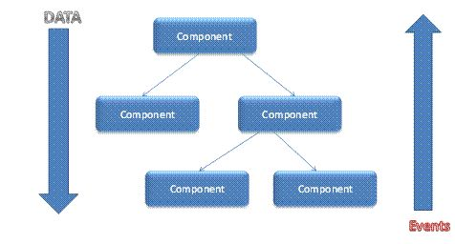
Fig 3.1 Reactjs components flow
Chapter 4
Project Details
The objective of this project is to develop a general purpose e-commerce store where any product (such as books, CDs, computers, mobile phones, electronic items, and home appliances) can be bought by buyer from the comfort of home through the Internet and seller can sell any product with simple process.
In this project detail explanation we will see different journey of both seller and buyer.
  - Seller’s Journey
Step 1: Registration / Login
Seller need to register himself/herself on the website only first time.
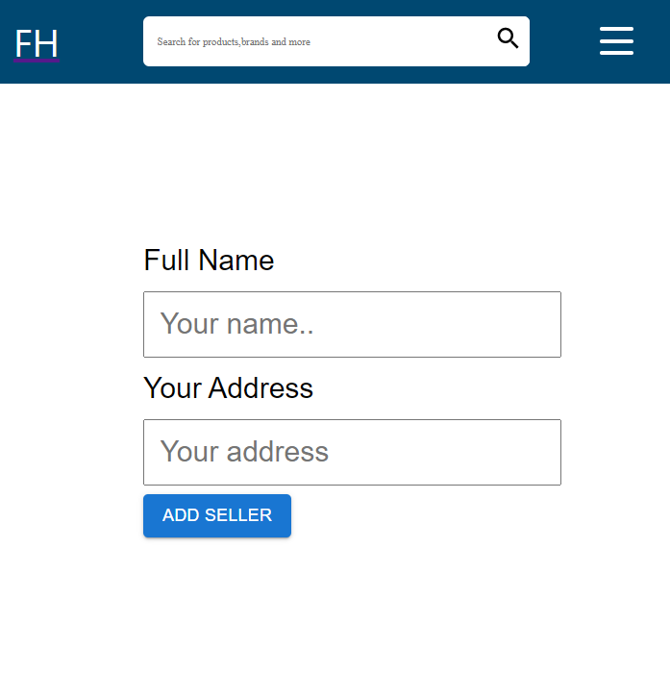
By Entering Name and Address then clicking on add seller button seller will be registered and redirect to home page.
If seller is already registered then He/She not need to fill this form again and again . they will automatically logined by only clicking on Seller button.
Step2 : Access Dashboard
Seller will get a dedicated Dashboard to manage all its products , orders.
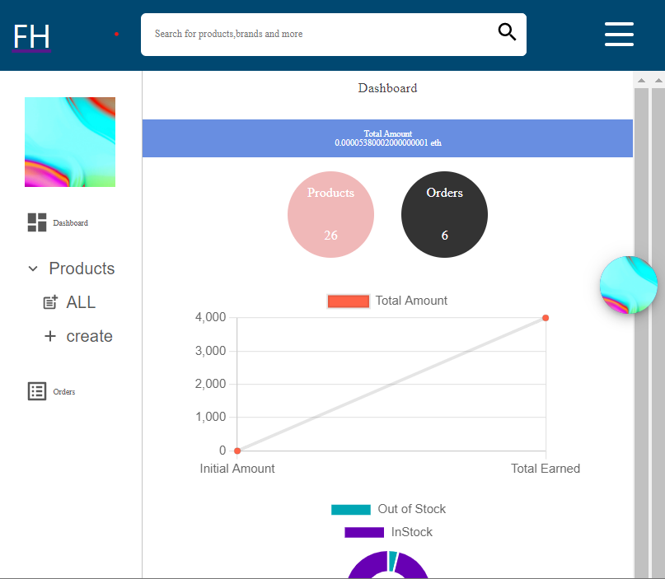
Seller can check total number of products create by him , total number of orders seller got for their products , number of products outofstock.
From here seller will be able to create new products , list all availabe products and orders.
Step3 : Create Product
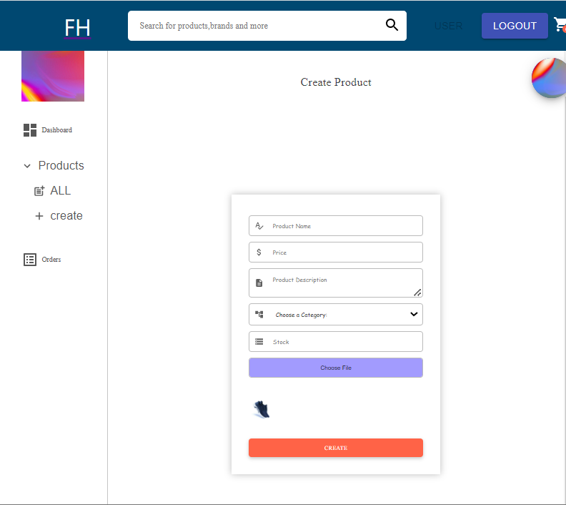
Seller can create new product by entering product name , price(In eth) , product description , category , stock and Image for product then clicking on create button .
Step4 : Listing all Available products
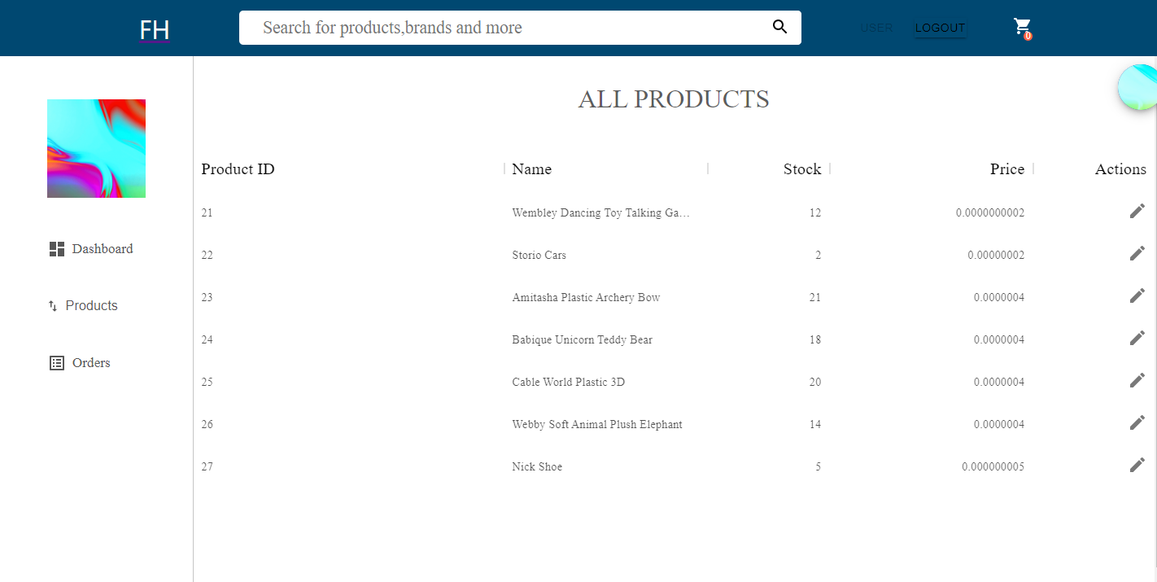
On this page seller can list all the products created by him/her . And check product’s name , stock , price , product id.
Step5 : List all orders
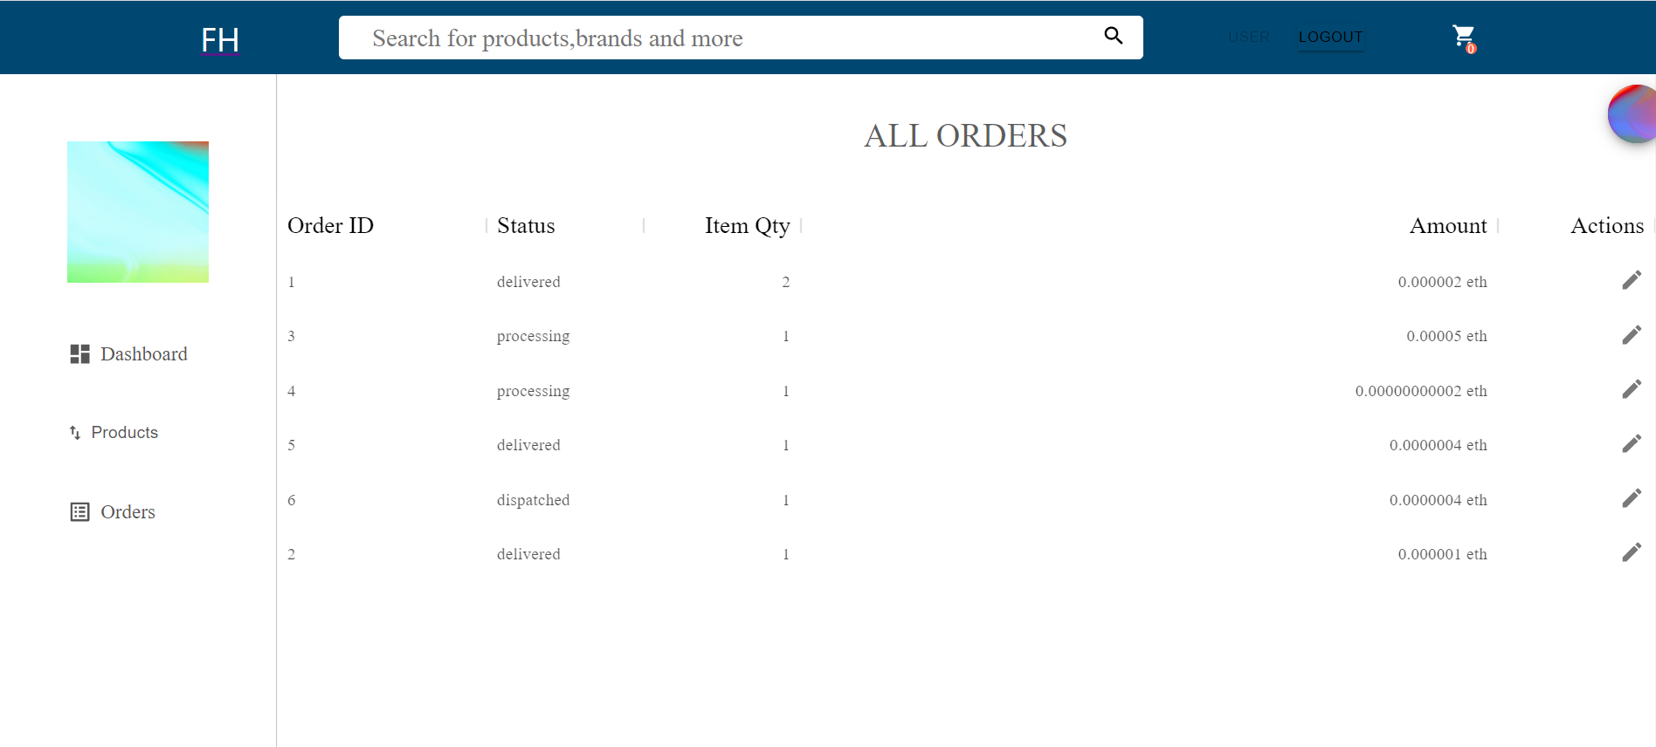
On this page seller can list orders . and status of order , item quantity in order , amount of order . on clicking on pencile icon seller can see details of order also update status of order.
Step6: Getting details of order , shipping info and updating order status
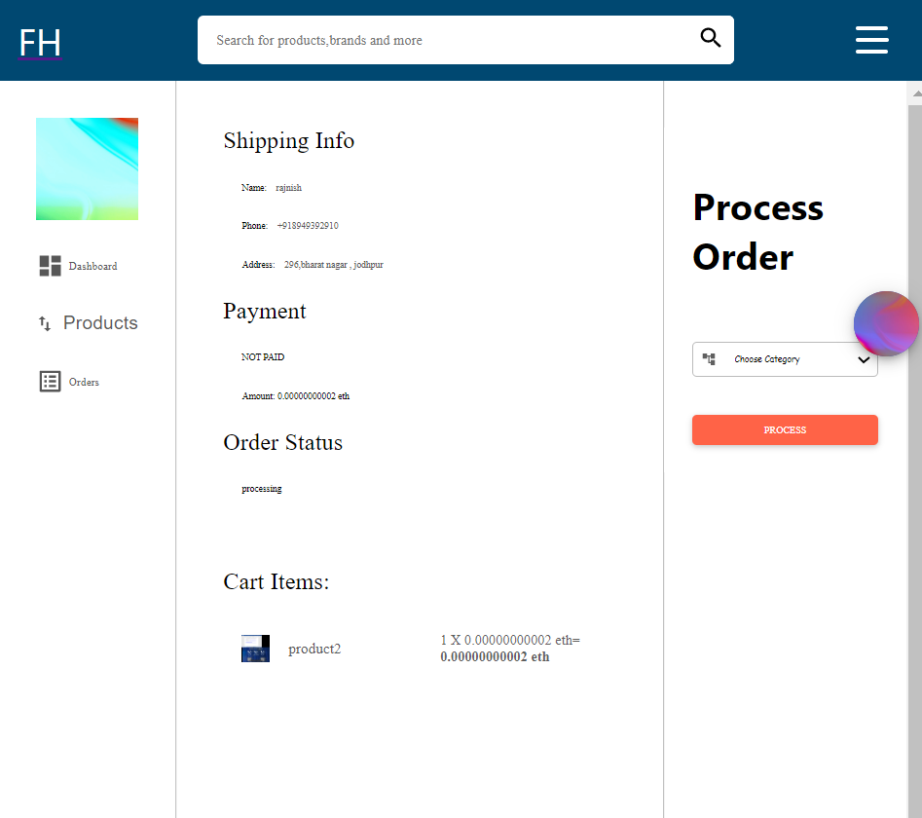
On this page seller can check details of order , shipping info , product quantity , total amount , order status ans payment status. Seller also will be able to update order status from processing to despatched. So that buyer can get to know status of their order.
  - Buyer’s Journey
Step1 : Register / Login
Buyer need to register himself/herself on the website only first time.
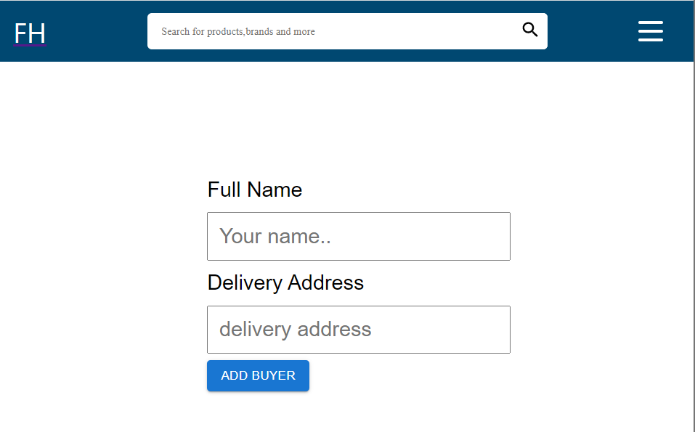
By Entering Name and Address then clicking on add buyer button buyer will be registered and redirect to home page.
If buyer is already registered then He/She not need to fill this form again and again . they will automatically logined by only clicking on Buyer button at Navbar.
Step2: Home page
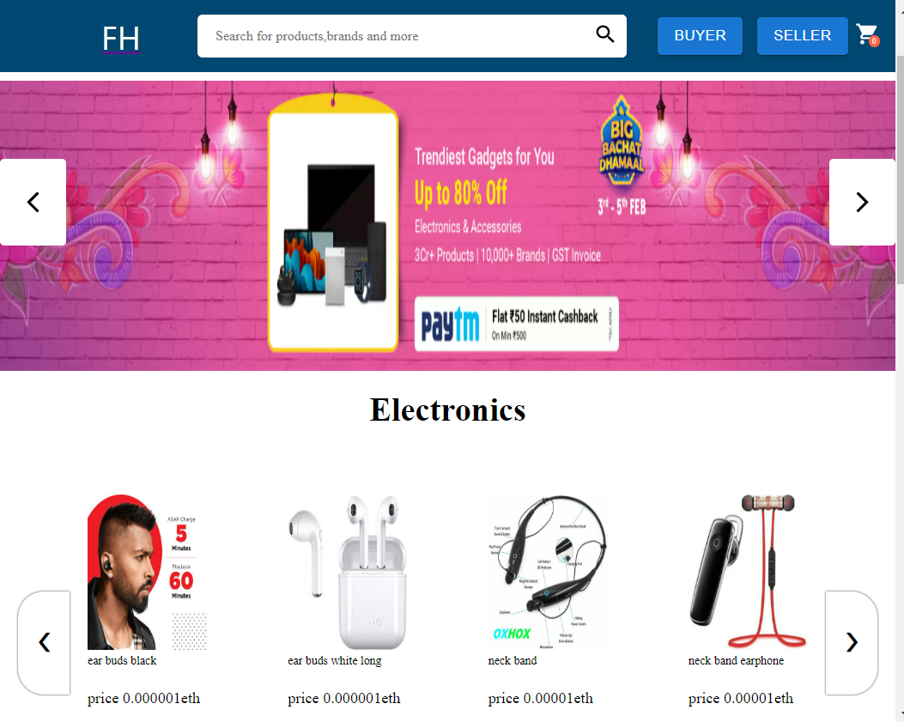
Buyer we see all the products created by differene sellers category wise . by clicking on any particular product buyer can see details of product.
Step3: Product Details
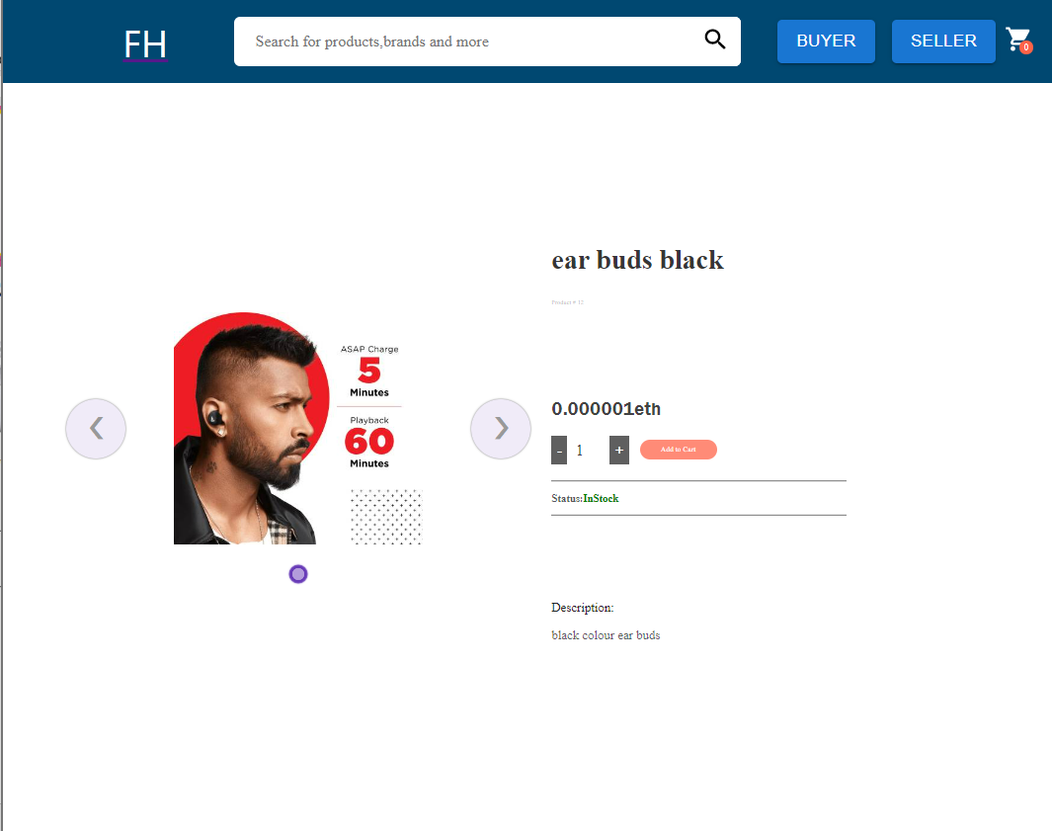
On this page buyer can see all the details realted to a product like name , price , status(out of stock , in stock) , description . they also can increase or decrese product qunatity .
And clicking Add to cart button product will be saved to user’s cart.
Step4: Cart
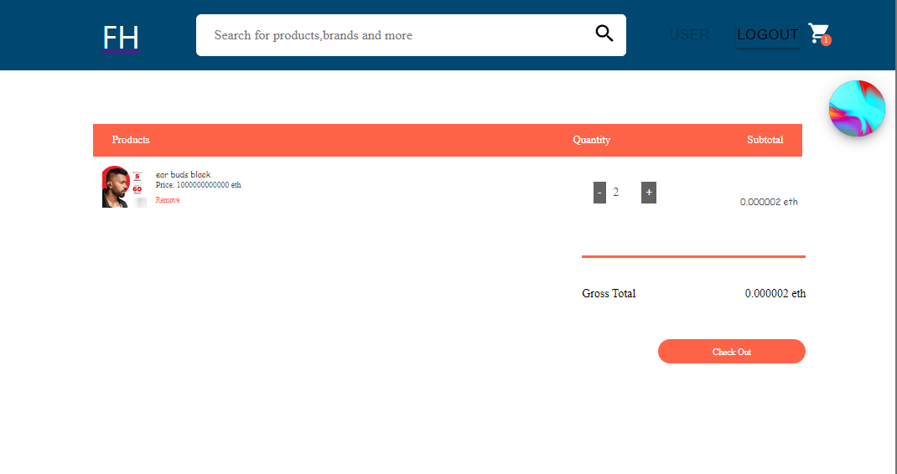
Here Buyer can see all the cart item added . from this page buyer can remove item from cart , increase or decrease qunatity , check total price and checkout for final preview.
Step5: Confirm Order
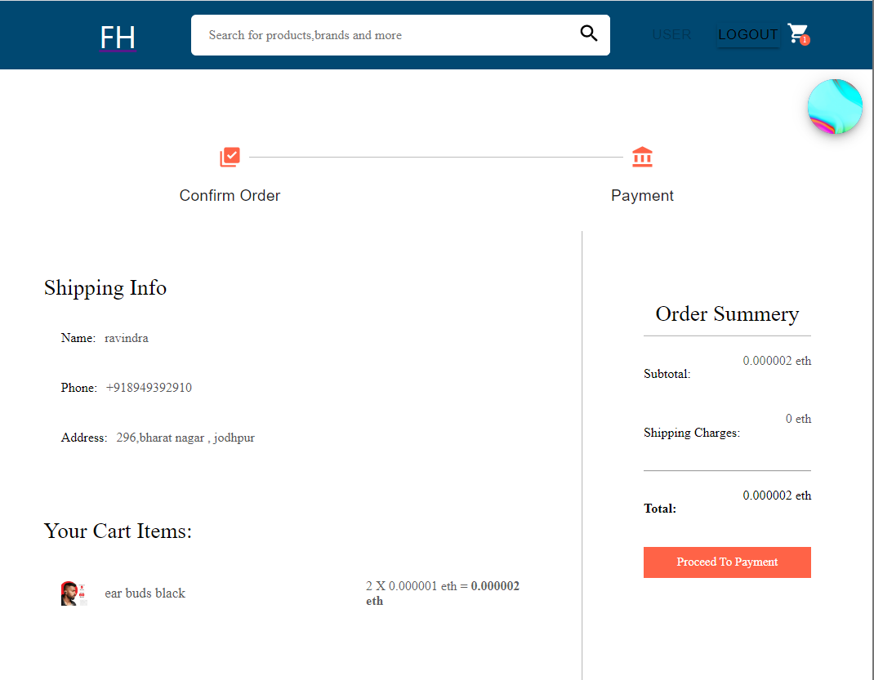
This is final preview before payment so that user can recheck shipping info , cart items , order summary .
Step6: Payment
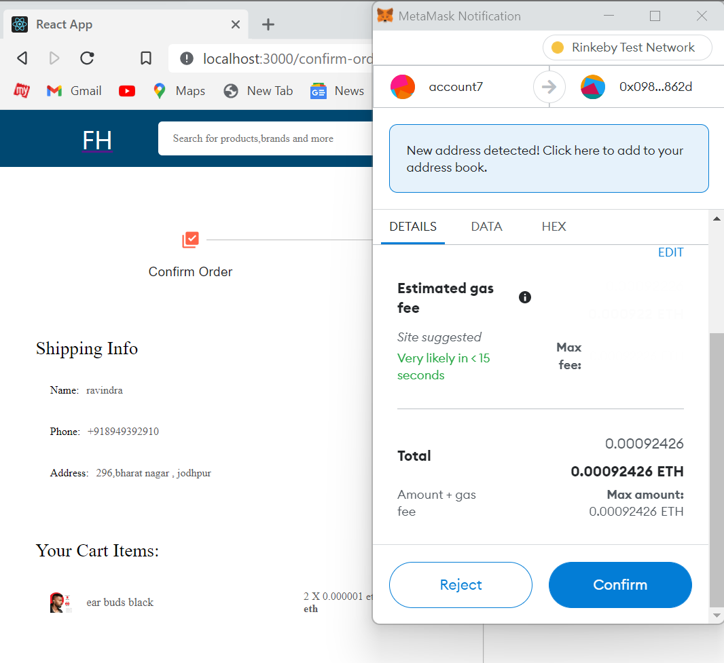
On clicking Payment button , Metamask will open and ask you to confim for payment .
This amount will to stored in smart contract account which will be released after buyer confirm prduct delivery .
Step7: My Orders Page
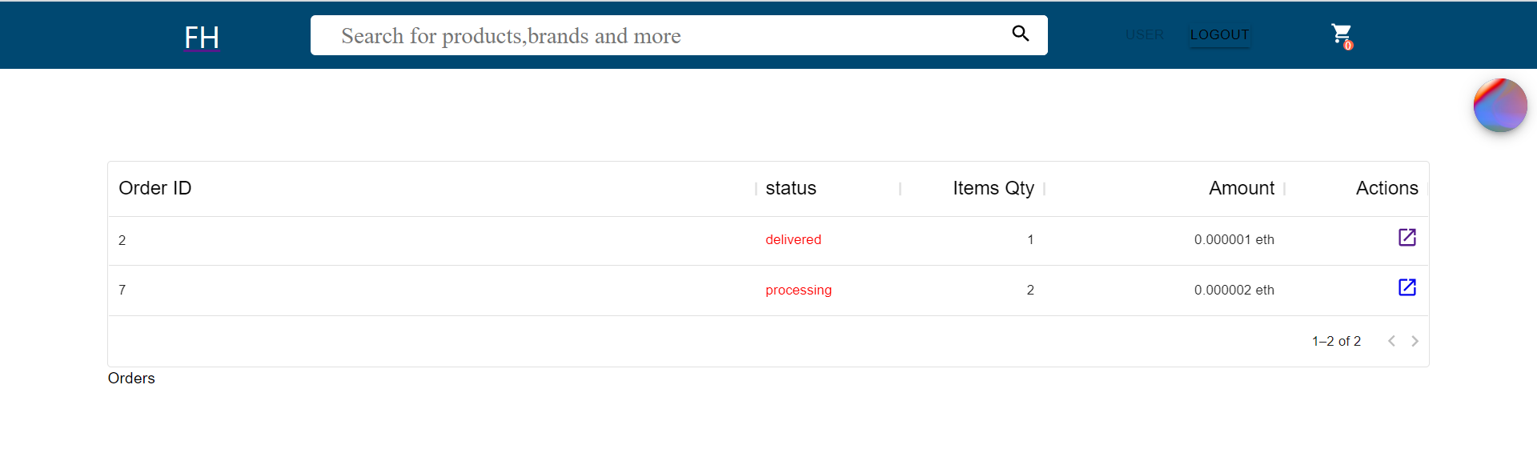
Buyer can check for their order status and further details of all the orders. And on clicking edit icon user can see order details of a particular order.
Step8: OrderDetails and Confirm Order
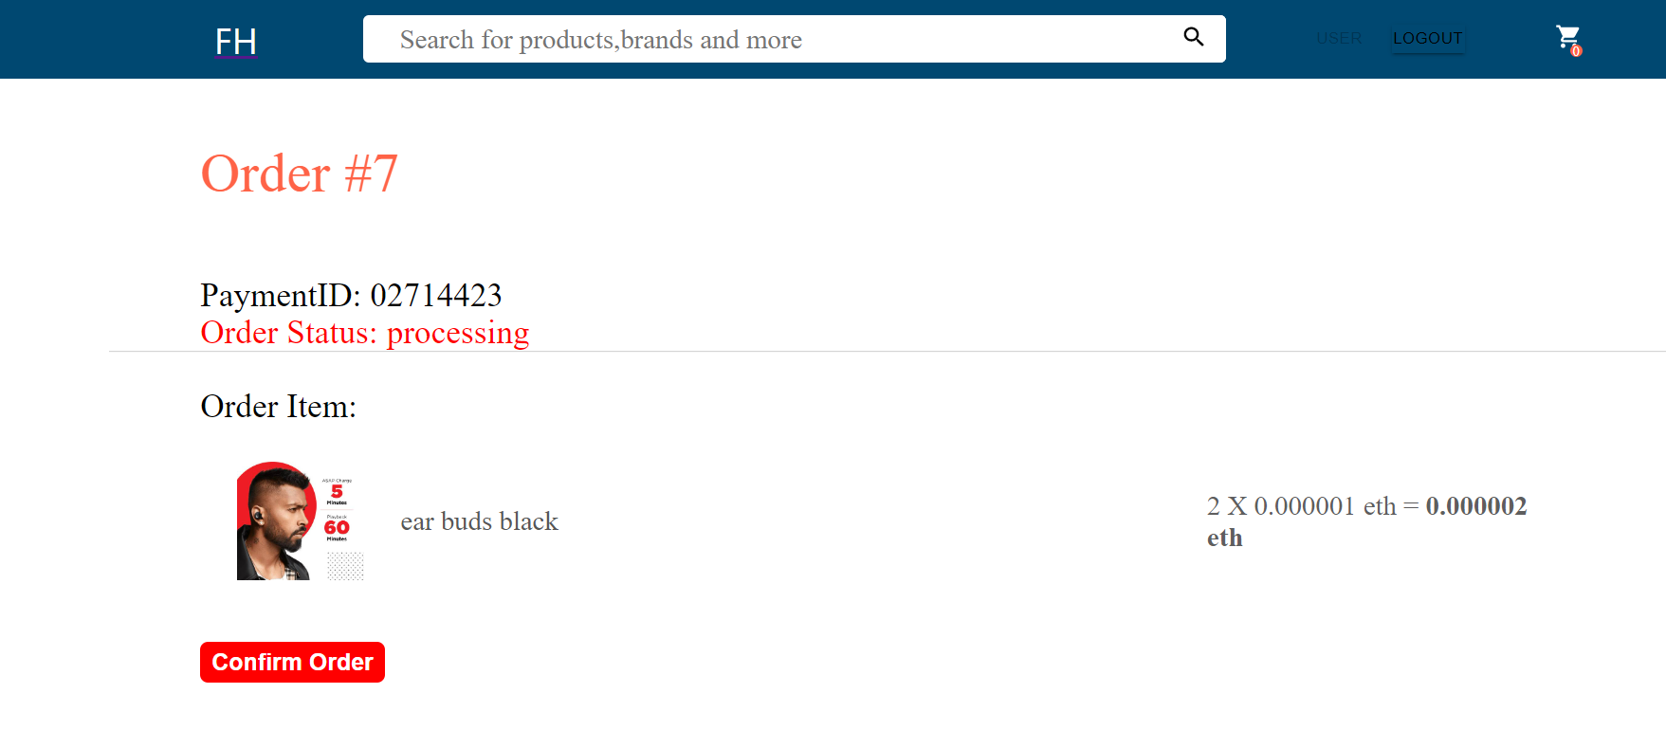
On this page buyer can see details of a order and see the status of order .
Step9 : Ordered Deliverd
When order get delivered delivery person will asked buyer to click that confirm order button so that amount that was stored in smart contract will be released to seller account. And order status will be changed to Deliverd and Payement Status will be Paid
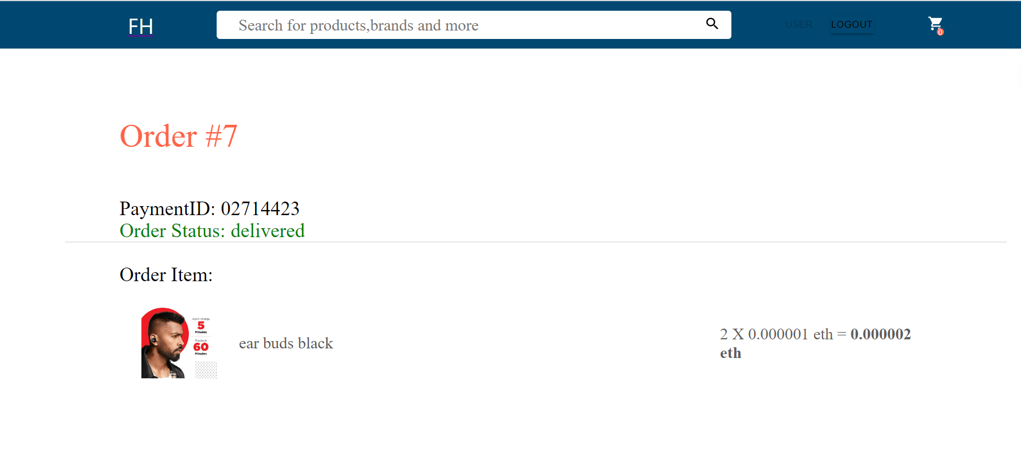
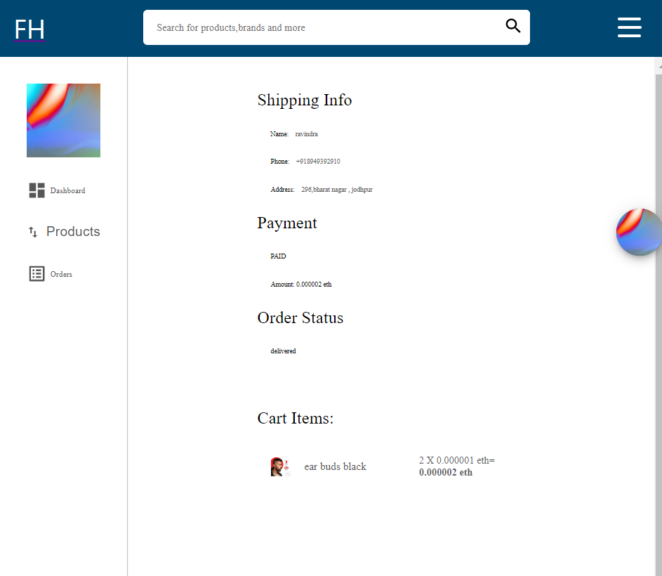

Chapter 5
Conclusion & Future work

  - Conclusion
So, in our final year project we have developed an E-Commerce DApp. Advantages it
has over traditional e-commerce websites are data security; faster transactions and no
centralized organization is involved. Because blockchain uses a distributed ledger, transactions and data are recorded identically in multiple locations. All network participants with permissioned access see the same information at the same time, providing full transparency. All transactions are immutability recorded, and are time- and date-stamped. This enables members to view the entire history of a transaction and virtually eliminates any opportunity for fraud.
Privacy issues can also be addressed on blockchain by anonymizing personal data and
using permissions to prevent access. Information is stored across a network of
computers rather than a single server, making it difficult for hackers to view data.
With blockchain, it is possible to share data about provenance directly with customers.
Traceability data can also expose weaknesses in any supply chain — where goods might
sit on a loading dock awaiting transit.
Transactions can even be automated with “smart contracts,” which increase your
efficiency and speed the process even further. Once pre-specified conditions are met,
the next step in transaction or process is automatically triggered. Smart contracts reduce
human intervention as well as reliance on third parties to verify that terms of a contract
have been met.
In this DApp, sellers upload their products and stock, there is no centralized org so
every seller gets equal opportunity. When buyer buys any product, they have to pay in ethers which are initially stored in smart contracts and release to seller only when buyer receive the product and satisfied with it, if buyer don’t get the product on time, then the ethers are revert back to buyer. And when buyer receive the product and satisfied with it, then only those ethers are transferred to the seller. So, there is a trust between both seller and buyer that this transaction is not fraudulent. It also provides data security, both seller and buyer have assurance that their personal data is free from data breaches.

  - Future work
- Search functionality on home page : Buyer will be able to search any product by using name , category or any realted keyword.
- Product Reviews and Rating : Buyer will be able to see reviews and ratings of product so that he/she can decide whether to buy product or not.
- Seller ratings and report : Buyer will be able to rate seller on the basis of their delivery and report if any issuse found in seller behaviour.
- Product return : Buyer will be able to return product accourding to term and conditions if they dislike that product . After returning of product they will get their amount back in account.
- Order cancellation: Buyer will be able to cancel order before delivery and will get product amount back in account.
- Chat Box : Buyer will be able to ask any query realted to product form seller.
References
- “What is Blockchain?” By ADAM HAYES on Investopedia -https://www.investopedia.com/terms/b/blockchain.asp , accessed on 25 June 2022.
- “What is Solidity Programming, its Data Types, Smart Contracts, and EVM in Ethereum?” on Simplilearn - https://www.simplilearn.com/tutorials/blockchain-tutorial/what-is-solidity-programming , accessed on 25 June 2022.
- “History Of Blockchain Technology: A Detailed Guide” by Gwyneth Iredale on 101 Blockchains - https://101blockchains.com/history-of-blockchain-timeline/#prettyPhoto , accessed on 25 June 2022.
- “Blockchain Dapp” by Alexander S. Gillis on techtarget - https://www.techtarget.com/iotagenda/definition/blockchain-dApp , accessed on 25 June 2022.
- IPFS docs IPFS gateway - https://docs.ipfs.io/concepts/ipfs-gateway/#overview
- Hardhat docs - https://hardhat.org/hardhat-runner/docs/guides/compile-contracts
- “What And Why React.js” by Nitin Pandit https://www.c-sharpcorner.com/article/what-and-why-reactjs/

